**Lesson: Mobile App Development – Transition Phase**

Pre-knowledge (Haiku Practice link)

Setup Xcode (diagram)

Hello World (Objective-C)

STEP 1 - .h file

______________________________________________

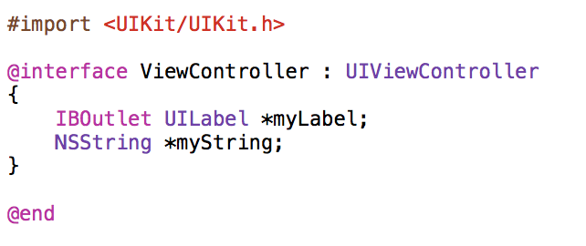

STEP 2 - .m file

______________________________________________

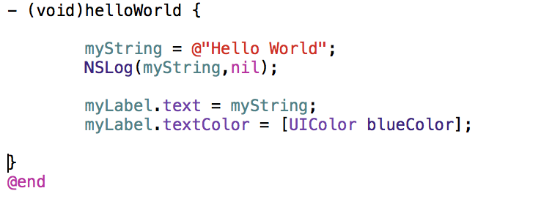

STEP 3 – calling a function within the same file

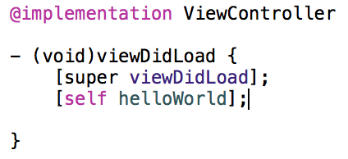

STEP 4 – IBAction: Interface Builder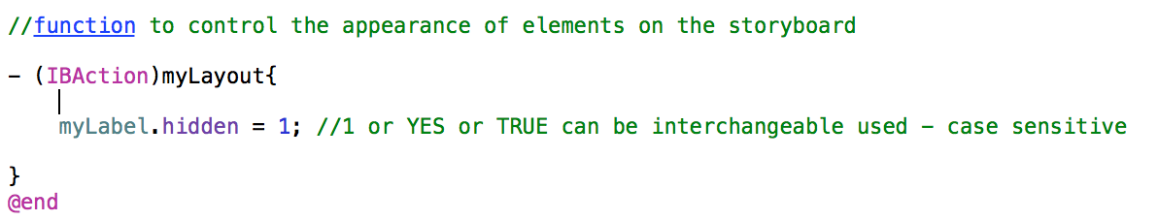

STEP 5 – Assigning outlets and actions in the Interface Builder which is associated with the STORYBOARD file.

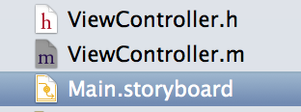

Interface Builder has two major areas: the dock (on the left) and the canvas (on the right). The dock lists the objects contained in the user interface file. The canvas is where you lay out these objects in your app’s user interface.

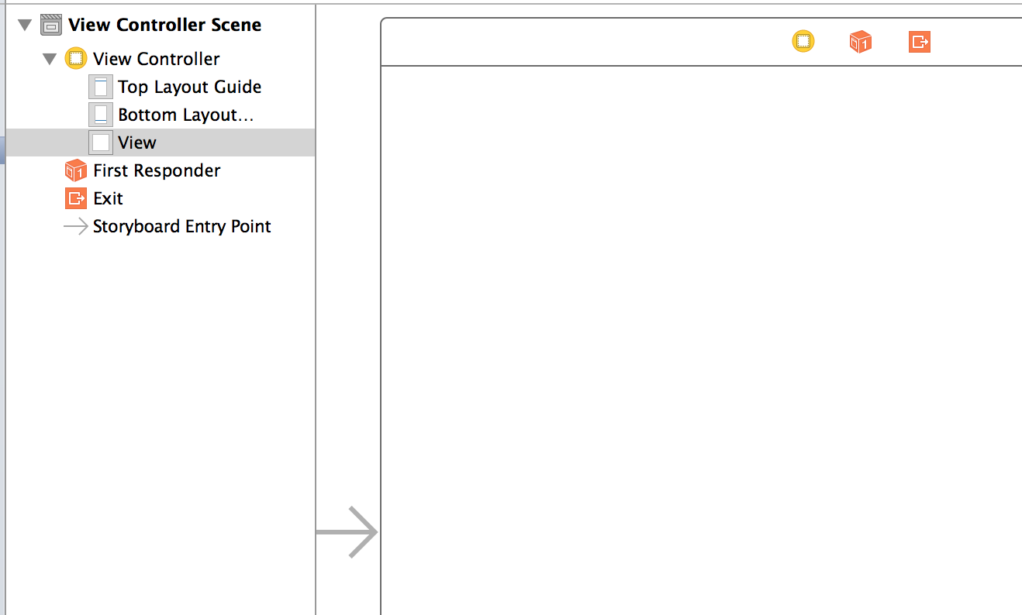

STEP 6 - Drag the LABEL and BUTTON objects to the canvas from the Object Library.

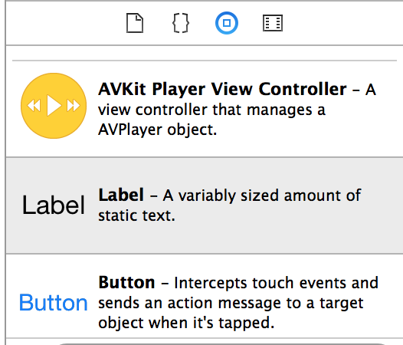

STEP 7 – Connect each objects with an ACTION by selecting the CONNECTION INSPECTOR

LABEL 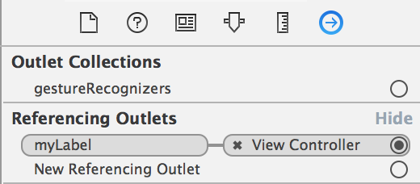

BUTTON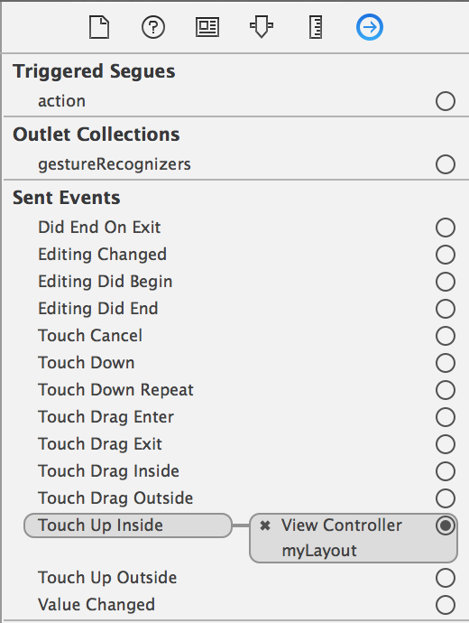

STEP 8 – Run SIMULATOR (PLAY and STOP) notice the object are not align. Explain the CONTAINER shapes (a square) which is not the same as the shape of the device

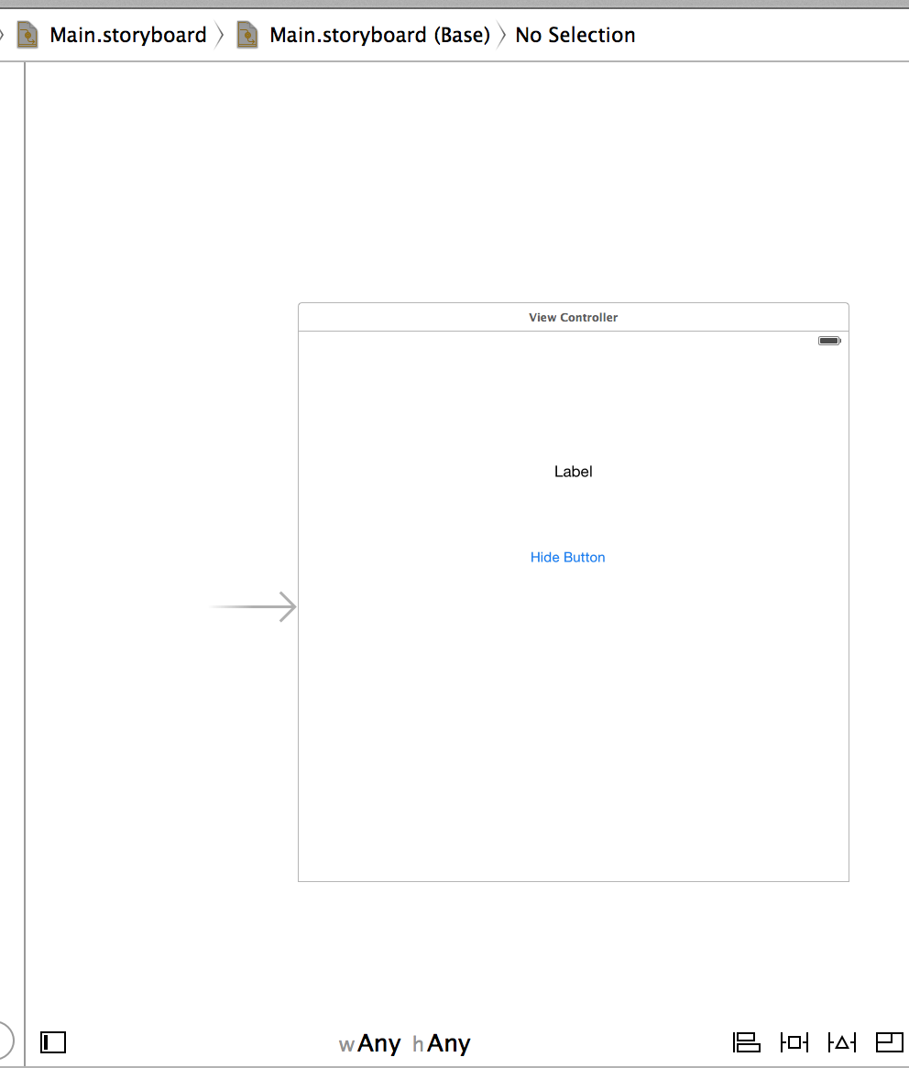

STEP 9 – Set up the CONSTRAINTS to allow the objects to be aligned properly (hold CONTROL) and select CENTER HORIZONTAL IN CONTAINER and CENTER VERTICAL IN CONTAINER

ALERT! ALERT! ALERT!

STEP 10 – add a new variable in the header file

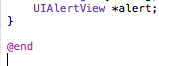

STEP 11 – then in the method file assign the properties of the variable

Weehawken:Users:guerrero:Desktop:Screen Shot 2015-04-10 at 4.32.17 PM.png

STEP 12 – create a SWITCH that will toggle the text’s visibility

Variable

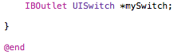

STEP 13 – back in the method file give the details of the new variable in the viewDidLoad function

Weehawken:Users:guerrero:Desktop:Screen Shot 2015-04-13 at 9.53.47 AM.png

Notice the exclamation mark ~ an IDE debug feature.

STEP 14 – fix the bug by declaring the selector switchChange. It is a new function

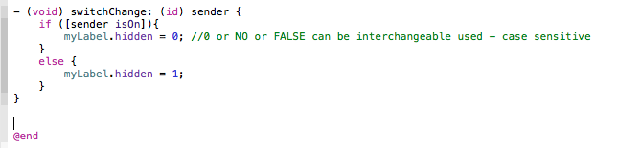

STEP 15 – and lastly we need to make sure it is in the IBAction function (myLayout) to control the animation

Weehawken:Users:guerrero:Desktop:Screen Shot 2015-04-13 at 10.03.36 AM.png

STEP 16 – lets put in a picture by declaring the variable(SSSSS); need a pair for this to work properly inside the header file

Weehawken:Users:guerrero:Desktop:Screen Shot 2015-04-13 at 10.07.46 AM.png

STEP 17 – drag the image in to the Navigation Area inside the top folder (HelloWorld)

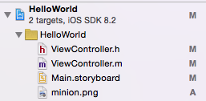

STEP 18 – and to conclude this code we need to assign the image in the method file in the viewDidLoad function

Weehawken:Users:guerrero:Desktop:Screen Shot 2015-04-13 at 10.13.46 AM.png

REVIEW – On Haiku go to the iOS Resources and read Xcode Overview